TEAM NO: 01
ROLL NO: SRENIDHI G P 24ECR195
SUNMATHI S 24ECR212
SUBIRAJ B 24ECR202

Offline Wi-Fi Port Communication between Raspberry Pi and Laptop

PROBLEM STATEMENT:
To create a local communication channel between a Raspberry Pi and a laptop using a WiFi module or hotspot without internet access. The communication will use TCP socket programming and a specific port number so both devices can send and receive messages.

REQUIRED HARDWARE:
- Raspberry Pi (any model with wifi)
- Laptop
- Wi-fi module / mobile hotspot / ESP32 access point
- MicroSD card

REQUIRED SOFTWARE:
- Arduino IDE
- Python3.10(64-bit)
- Raspberry pi OS
- Python Socket Library
- Terminal
WI-FI CONNECTION FOR ESP32:
#include <WiFi.h>

const char* ssid = "Vivo Y28";
const char* password = "_____";

void setup() {
Serial.begin(115200);

Serial.println("Connecting to WiFi...");

WiFi.begin(ssid, password);

while (WiFi.status() != WL_CONNECTED) {
delay(1000);
Serial.println("Connecting...");
}

Serial.println("WiFi Connected!");
Serial.print("IP Address: ");
Serial.println(WiFi.localIP());
}

void loop() {
// Nothing needed here
}

CREATE A SERVER ON RASPBERRY PI:

import socket
host = '10.235.28.211'
port = 5000
server = socket.socket(socket.AF_INET, socket.SOCK_STREAM)
server.bind((host, port))
server.listen(1)
print('Waiting for connection...')
conn, addr = server.accept()
print('Connected by', addr)
while True:
data = conn.recv(1024)
if not data:
break
print('Received:', data.decode())

Run the server:
python3 server.py

CREATE CLIENT ON LAPTOP:

import socket
host = '10.235.28.211' # Raspberry Pi IP
port = 5000
client = socket.socket(socket.AF_INET, socket.SOCK_STREAM)
client.connect((host, port))
message = 'Hello from laptop'
client.send(message.encode())
print('Message sent')

Run the Client
python3 client.py

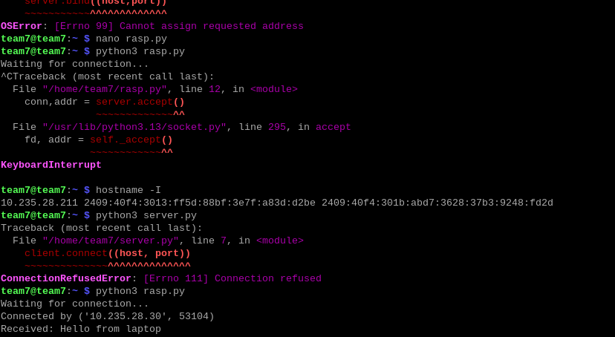
FOR EITHER SIDE COMMUNICATION
(Raspberry Laptop):

SERVER CODE:
import socket
host = '10.235.28.211' # Raspberry pi IP
port = 5000
server = socket.socket(socket.AF_INET, socket.SOCK_STREAM)
server.bind((host, port))
server.listen(1)
print("Waiting for connection...")
conn, addr = server.accept()
print("Connected by", addr)
while True:
# Receive message
data = conn.recv(1024)
if not data:
break
print("Laptop:", data.decode())
# Send reply
message = input("Pi: ")
conn.send(message.encode())
conn.close()

CLIENT CODE:
import socket

host = '10.235.28.211'
port = 5000

client = socket.socket(socket.AF_INET, socket.SOCK_STREAM)
client.connect((host, port))

print("Connected to Raspberry Pi")

while True:
# Send message
message = input("Laptop: ")
client.send(message.encode())

# Receive reply
data = client.recv(1024)
print("Pi:", data.decode())

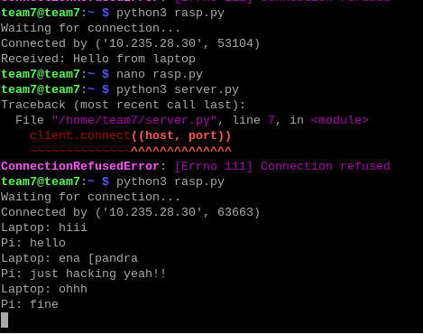
OUTPUT:

OVERALL FLOW:
Setup the devices (lap & rasp) with same wi-fi network

Note the IP address of both devices
For rasp: hostname -I
For lap: run the wi-fi code note the
IP from serial monitor

Make raspberry pi as the Server

Make laptop as the Client

Run the code
Rasp: python3 server.py
Python terminal: python client.py

Communication begins between two devices
without separate network access(thorough
local network)

RESULT:
Thus the ESP32 successfully created a wi-fi Access point through which laptop and raspberry pi connected and communicated each other. Allowing real-time dual side communication between devices without internet access has been done through the specified port (port:5000).

